USER INTERFACE AND USER EXPERIENCE DESIGN LAB
NAME : MIDHULA PRIYIAN P V
REG.NO : 23MIS0609
SLOT : L15+L16
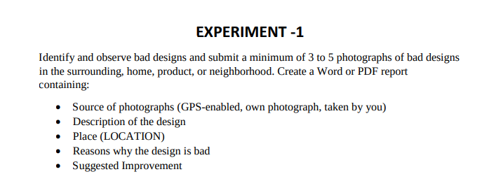
Bad Design 1: Inaccessible Electrical Switch Board

Description:

The electrical switchboard that controls the classroom lights and fans is installed inside a locked electrical cabinet. Students cannot directly access the switches, and the location of the switchboard is not clearly visible. Many first-year students spend time searching for the controls or depend on faculty or staff to operate them.

Source of Photograph:

Own Photograph (GPS-enabled, Captured by Me)

Place:

SJT Block, VIT University, Vellore, Tamil Nadu, India

Reasons why the design is bad:

- The switchboard is inaccessible to students.

- Lack of proper visibility and signage makes it difficult to locate.

- Users cannot independently control lights and fans.

- Wastes time, especially for new students.

- Reduces usability and user convenience.

Suggested Improvement:

Install a separate, easily accessible switch panel outside the electrical cabinet.

- Add clear labels or directional signs indicating the switchboard location.

- Place commonly used switches at an ergonomic height.

- Ensure authorized but convenient access for classroom users.

Bad Design 2: Poor Placement of Face Recognition Biometric System

Description:

The face recognition biometric attendance system is installed near the classroom entrance. Students can mark their attendance immediately after entering and then leave the classroom without attending the lecture, reducing the effectiveness of the attendance system.

Source of Photograph:

Own Photograph (GPS-enabled, Captured by Me)

Place:

SJT Block, VIT University, Vellore, Tamil Nadu, India

Reasons why the design is bad:

- Attendance can be marked without actually attending the class.

- Does not ensure students remain inside the classroom.

- Reduces the reliability of the attendance system.

- Allows misuse and decreases discipline.

- Poor placement affects the intended purpose of the biometric system.

Suggested Improvement:

- Install the biometric device inside the classroom near the faculty desk.

- Allow attendance only after the faculty initiates the process.

- Integrate attendance with class timing or periodic verification.

- Use additional monitoring methods to prevent misuse.

---

Bad Design 3: Insufficient Bag Storage Area

Description:

The designated bag storage rack provided outside the classroom is too small for a class of around 70 students. As a result, many students place their bags on the floor, occupying walking space and creating inconvenience.

Source of Photograph:

Own Photograph (GPS-enabled, Captured by Me)

Place:

SJT Block, VIT University, Vellore, Tamil Nadu, India

Reasons why the design is bad:

- Storage capacity is insufficient for the number of students.

- Bags placed on the floor obstruct the walkway.

- Increases the risk of tripping and accidents.

- Makes the corridor look untidy and crowded.

- Difficult for students to locate and retrieve their bags.

Suggested Improvement:

- Increase the size and capacity of the bag storage racks.

- Provide multiple storage units based on class strength.

- Design vertical shelves with numbered compartments.

- Ensure the storage area does not block the walking path.

